CS1050 Technical Documentation
Use headings to organize topics and create a table of contents to be able to quickly access information.

After adding new headings to organize your documentation, refresh the table of contents below.
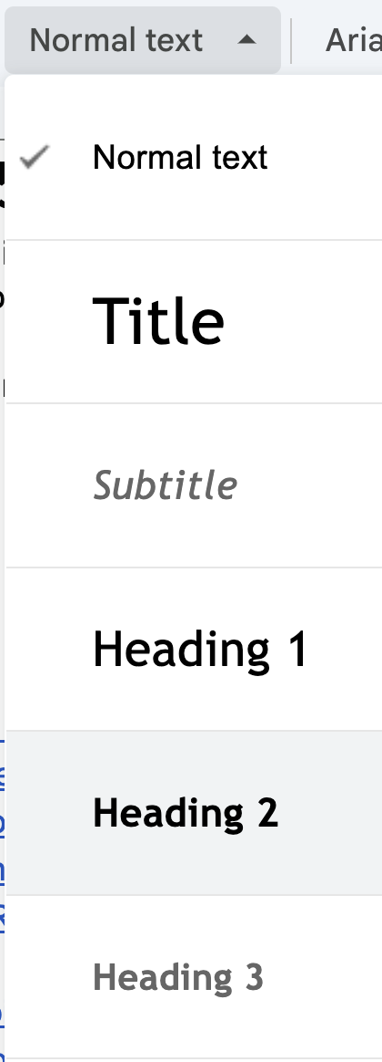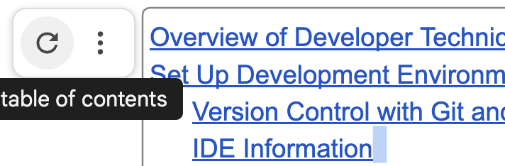

Overview of Developer Technical Documentation
Set Up Development Environment
General Resources
Module 01: Fundamental Programming Concepts
Compilation and Errors
Primitive Data Types, Variables, Constants, and Naming Conventions
Arithmetic Operators and Combined Assignment Operators
Memory Allocation, Conversion and Casting
Code Sample
ANY OTHER TOPIC?
Module 2
Module 3
Module 4
Module 5

Follow the 4 tips from Part 2: Developer Technical Documentation:
Importance of Being Concise:
- Developers need clear and precise answers.
- Use short sentences, small paragraphs, and simple language.
- Avoid unnecessary complexity to improve clarity.
Avoiding Technical Jargon:
- Simplify writing to ensure accessibility.
- Use standard industry terms if technical language is necessary.
Using Code Snippets:
- Show what the product can do with practical examples.
- Elevates documentation quality by catering to developer familiarity with code.
Role of Visuals:
- Screenshots, GIFs, and videos enhance engagement and understanding.
- Visuals simplify complex processes and reduce lengthy explanations.

Overview of Developer Technical Documentation
I use headings to help organize and easily access information. I like to include snippets of code that contains comments as an easier way to have documentation. You can put in the document what is helpful for you.

Use information from class lectures, guided exploration, code examples from class and book to be able to use later to help you and approach it as if you could help someone else.

GE 01 Put technical documentation below to demonstrate your understanding of Module 1:
- Understand and set up the programming environment (Eclipse, Git, and GitHub).
- Apply version control using Git and document changes effectively.
- Write basic Java programs using variables, constants, and logical structures.
- Debug code using Eclipse IDE and reflect on common syntax and logical errors.
- Develop concise and structured technical documentation.

Set Up Development Environment
Provide the following but you can copy and paste my steps and add any additional or update my information for you. Make your documentation your own but follow best practices. Create headings that make sense to you.
- Overview of tools
  - Eclipse IDE for Java development
  - Git and GitHub for version control
- Git and Github
  - Overview of tools
  - Steps to set up
  - Steps to use desktop ( or command line if you know it) to version locally and back up on server
- Set Up IDE (Eclipse):
  - Overview of you IDE
  - Steps to install
  - Configure the workspace to store projects.
  - Verify JDK installation.
  - Creating future projects and class files
  - Use IDE for debugging -

General Resources
Here you can list resources that you use frequently and keep adding to them over the course of the class (lectures, book, tutorials, etc)
- Shared student CS1050 resources
- [ADD OTHER RESOURCES]

Git:
GitHub: repository

Module 01: Fundamental Programming Concepts

Add information for each subheading below. I have some information to get started

Compilation and Errors

For examples here are some code resources on errors
- SyntaxErrors
- RuntimeErrors
- LogicErrors

Syntax Errors

- Occurs when the programmer either misspelled, correct capitalizations or not, missing a letter or punctuations and special characters. Above all, incorrect grammar.

Runtime Errors

- Runtime error occur while the program is running and not before executing the code.

Logic Errors

- Logic errors are when a program gives unexpected or wrong results than what you’re looking for, but the syntax is correct.

Compile Errors

- An error in the program that can’t run
- This is also a scoped out body
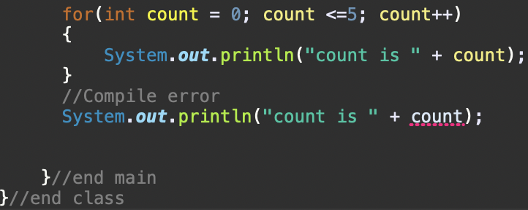

____________________________________________________________________________

Primitive Data Types, Variables, Constants, and Naming Conventions

This website describes primitive data types Java Data Types - javatpoint

- boolean data type
- Single bit of information that can take two possible states
- True or false
- 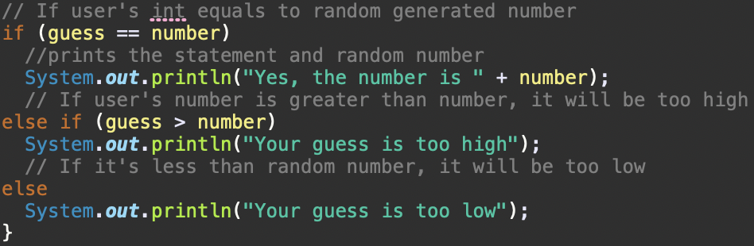

- byte data type
- 8-bit signed two’s complement integers (1 byte)
- Range of values from -128 to 127
- Default value 0
- Example: byte a = -58 byte b = 11
- char data type
- Single character (2 byte)
- Represent character, such as letters, digits, and symbols
- Uses ‘ ‘
- short data type
- 16-bit signed two’s complement integers (2 bytes)
- Range of values -32,768 to 32,767
- Default value 0. More precision than byte is required
- Example: short s = 22,948 short r = -2020
- int data type
- 32-bit signed two’s complement integers (4)
- Range of values -2,147,483,648 to 2,147,483,647
- Default value 0. Typically used to store whole numbers without decimal points
- Example: int a = 1000000 int b = -200000
- long data type
- 64-bit signed two’s complement integers (8 bytes)
- Range of values -9,223,372,036,854,775,808 to 9,223,372,036,854,775,807
- Default value 0.0F
- Example: long a = 100000L long b = -200000L
- float data type
- Single-precision 32-bit IEEE 754 floating-point numbers (4 bytes)
- Wide range of decimal values
- Example: float f1 = 234.5f

- double data type
- double-precision 64-bit IEEE 754 floating-point numbers. (8 bytes)
- Default value 0.0d
- Wider range of decimal values than float
- Example: double d1 = 12.1234567890

Non-Primitive Data Types: Classes, Strings, Arrays, Interfaces
____________________________________________________________________________

Class Identifier

- Java is case sensitive so sum(Variable), Sum(Class), SUM(Constant) are 3 different identifiers

Package

- Organizes classes and interfaces
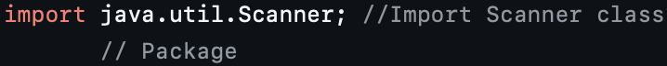

Method

- Can have parentheses
- Example: .pow
- Example: println()

Class

- Starts with an uppercase letter
- It is a blueprint for creating objects

Data types

- Tells compiler what type of data that is stored
- You must declare the type of each variable

Compiler

- Translates high level language into machine language for the computer to read

Variables and Naming Conventions
Store a value that may change (vary), have a data type, stored in computer memory,
have scope - defines
● Naming a variable:
Use meaningful names
Begin with lowercase Multiple-word
identifiers camel case

Example: myName = Alexis;

● Declare and Initialize: can declare
and initialize variables in one step
Declare variables by defining what data type (amount of memory needed to store the
value)
Initializing a variable: assign an initial value to the variable (before it is used at all).
Declare int into quiz1 and initialize 10 into the variable

Constants
- A variable that doesn’t change when the program runs
- finale is a constant
- Usually written all uppercase with an underscore gap/s to separate words

I declare

Allocate enough memory

Arithmetic Operators and Combined Assignment Operators

Addition:

- +
- Left to right
- Example: 10 + 5 = 15

Subtraction:

- -
- Left to right
- Example: 10 - 5 = 5

Multiplication:

- *
- Example: 10 * 3 = 30

Division:

- /
- Example: 10 / 3 = 3, 1.0 / 2.0 = 0.5

Remainder:

- %
- Example: 10 & 3 = 1

Memory Allocation, Conversion and Casting

Memory is allocated to a location in a unique address to store variable’s value

Double classPart = 90.2
Allocate memory for double, identifier needs a value, 90.2 initialized variable

Implicit Casting
- Casing a value with a smaller range to one with a bigger range
- Java does this automatically
- Example: double d = 3;

Explicit Casting
- Casting a value with a bigger range to one with a smaller range
- Must do it explicitly because we can lose data
- Example: int number = (int) 3.0;

Casting: Converts one data type to another

Code Sample
Add code from the guided exploration that contains comments - notes to help you understand the parts of the code.
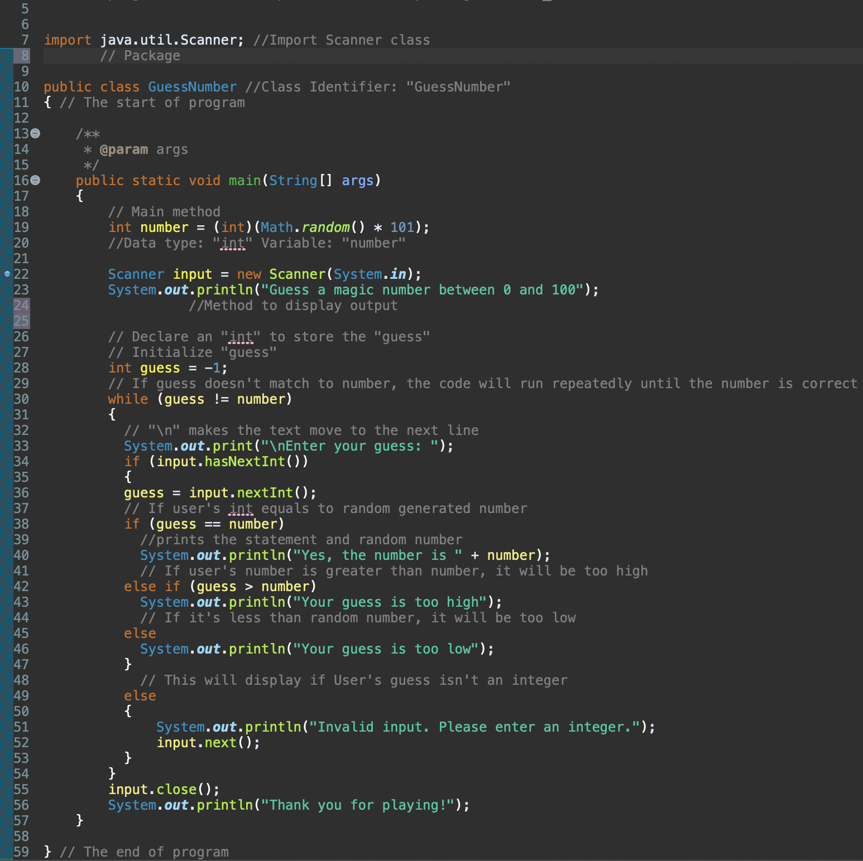

ANY OTHER TOPIC?

Module 2
[ADD Headings 2 for the different topics then add your documentation from the lectures]

Predefined Classes, Methods and Decisions Structures

Classes, Objects and Methods

Method - Methods are used to have a computer program do an action when the program calls the method, returns values.
- Methods have parentheses after the method name

Println is a method where the program displays the statement where it asks the user if they like dogs. The next(); is also a method where the user can type out a response to the question.

Class - A class is a blueprint for creating objects
- Variables: represent what attributes goes in the object, and initialize objects
- Define methods

Scanner Class - A container for methods to read input, like information from the keyword (console)
- To use a scanner you must import a Scanner First

Math Class, Character & Strings

Math Class
- We don’t create an object for a Math class like for Scanner class
- All methods in Math Class are static methods
- Static method:
- This allows you to call a Math Class without having an object
This class helps you call a Static method

Math Methods

- Math class is imported by default
- Performs mathematical functions and performs beyond basic operations:
- +, -, *, /, %
- Java Math class with Mathods - Javatpoint
- Resources when I need to use math methods

Constructor - This is a method that is called to “create” an object

Overload methods - If a class has the same name but more methods is considered Method Overloading
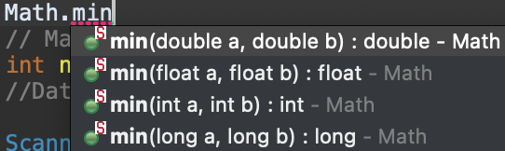
____________________________________________________________________________

Char Data Type
- Use single quote to represent a character (‘ ‘)
- Char variable can only hold one single character
- It is a primi
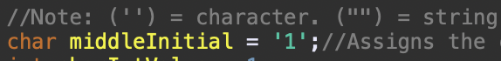

- Input.charAt(0) is a command that the user will input one char in keyboard
- The (0) represents the very first slot that is going to be displayed
- Example: Alexis, the letter A will be displayed
____________________________________________________________________________

String Data Type

- A string data type uses double quotes (“ “) to represent a string
- A sequence of characters is a string
- Not a primitive data type
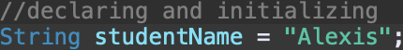

String Methods

- Length() - returns the number of characters in a string
- charAt(index) - Returns the character at a specific index within the string
- First char is positioned to 0
- Example 1: Alexis, A is 0 and l is 2 and so on

Concatenating Strings - this is a method that combines specified strings to another string. It returns a combined string

Trim String White Space Characters

trim() - this returns a string with all white space characters removed from front and end of the string
White space characters - space, tab, line, feed, form feed, carriage return

Decision Structure and Career Plans

Flow Control - The order of how the program goes to get executed

Relational Operators

> - Greater than
< - Less than
>= - Greater than or equal to
<= - Less than or equal to
== - Equal to
!= - Not equal to
These are all operators

Note*
== - This is used when both sides are equal
= - This is used when a literal is being assigned into a variable

Boolean Data Type

- Yes / No
- True / False
- On / Off
- If/else - This statement chooses which if a condition is true

Two Way Selection Structure

- The if/else statement is a double-selection statement, it can only select one condition between two different actions
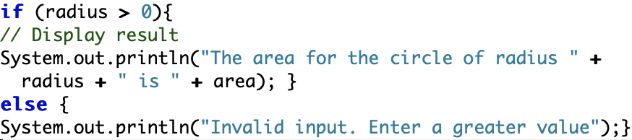
If radius is greater than 0, the program will display the area of the circle. If not, the program tells the user to input a greater value.

Scope - Scope is the area of the program where a variable is referenced
- Between the braces ({})

Scope: if else block
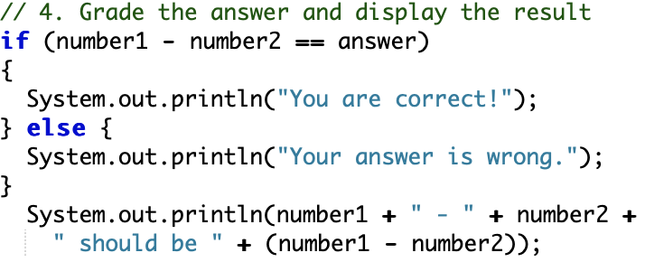
Declared by braces where it stars ({) and ends (}). The last system is out of the scope because it is not inside of the if block.
____________________________________________________________________________

Logical Operators, Multi and Nested if-else and Switch Statements & Switch Branching and Strings/Chars

Nested if
- Always indent code in the body of an if-statement
- You can place an if-statement inside of another if-statement

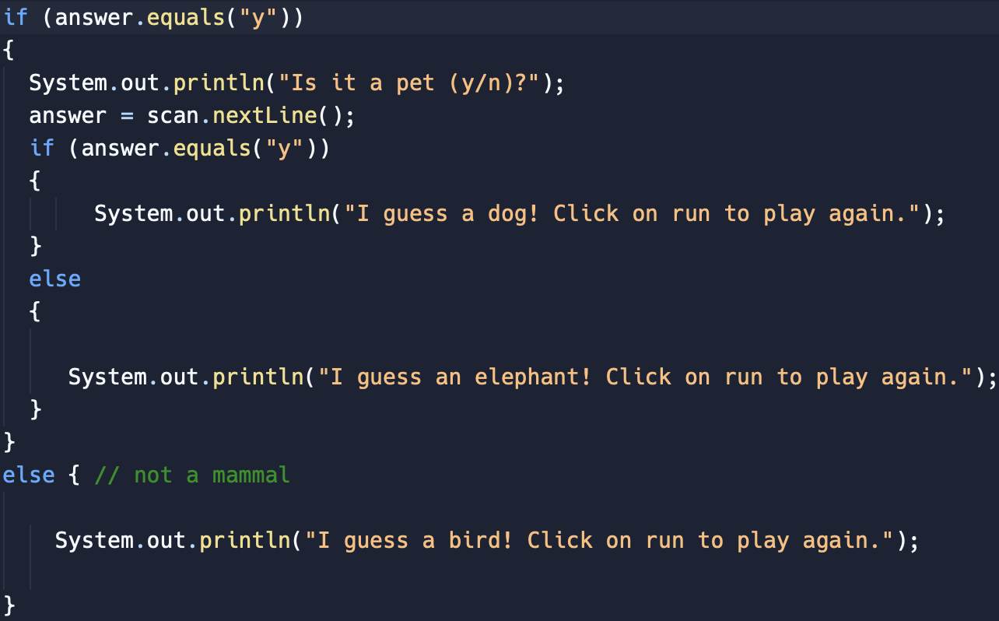
This is a nested if-statement. You can see there is an if-statement at the very top checking if the answer is “yes” and then there is another if-statement in the previous one where the program is asking the user if the mammal is a pet.

Multi-Way if/else

- This is used when only one condition can be true
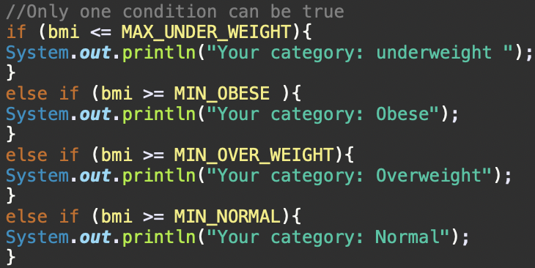

Logical Operators

! Operator

This is a Not (!) operator, this returns the logic such as false is true and true is false. For example, if the user is not hungry then they won’t eat lunch, but if they are hungry then they’ll eat lunch.

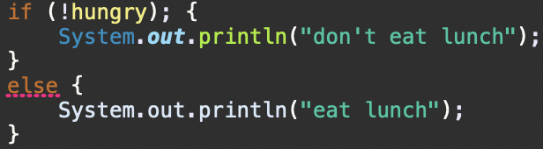

|| Operator

This is an Or (||) operator where one variable is true that the dog has to poop, but one that is false that the dog doesn’t have to pee. If one condition is true then the dog will still go outside, vise versa as well or if both are true. However, if both statements are false then the dog will stay inside.

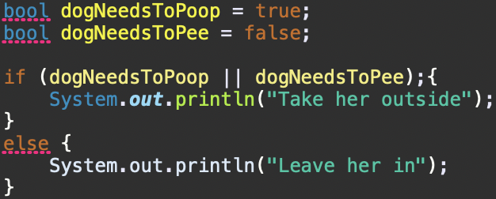

&& Operator

This is an and (&&) operator where if blue and red are true, the outcome should be purple but if not then you are color blind. Both statements are true so purple has to be displayed.

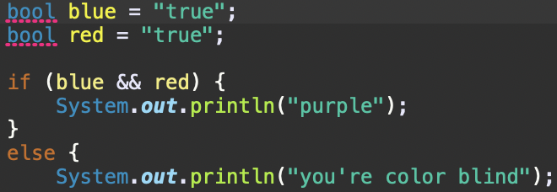

Switch Statement

- Switch statement is used for matching a constant value of a char
- The break command can be only used in a switch statement
- Switch-expression must always be enclosed in parentheses
- Yield a value of char, byte, short, or int
- Cannot contain variables

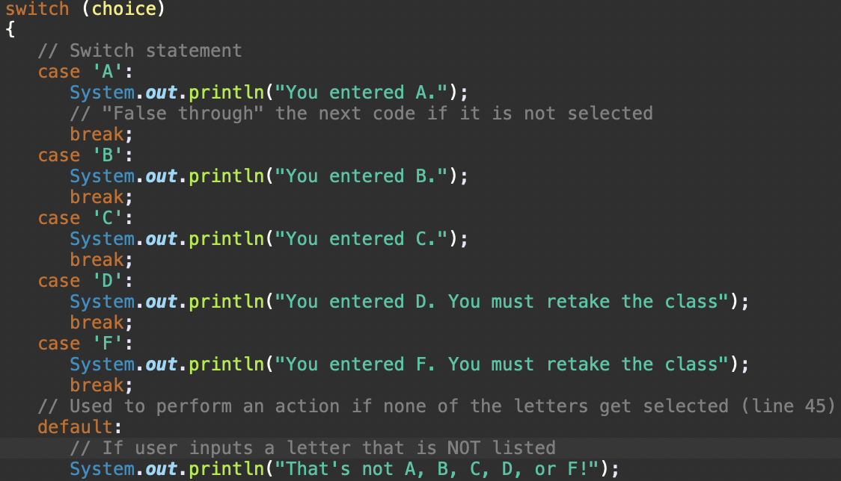

Note* - Use an if-statement to test for boolean conditions
- Use a Switch statement where matching a constant value of type char or int

Module 3
[ADD Headings 2 for the different topics then add your documentation from the lectures]

Loops

Increment and Decrement Operators
Increment
- (++)
- Adds a value by 1

Decrement
- (- -)
- Subtracts a value by 1

Postfix
- x++/- -
- Increases/decreases the value of the variable by 1 after the value is used in the expression

Prefix
- ++/- -x
- Increases/decreases the value of the variable by 1 before the value is used in the expression

Iterative Control Structures
While Loop
- While loop iterates a block of code as long as it remains true. Other words, the block if code will keep on running until it is false
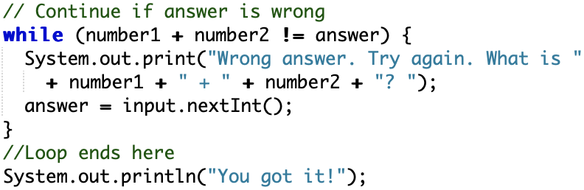
- While user inputs wrong answer from number1 + number2 the loop keeps repeating
- Loop ends when the answer is right
- Doesn’t need a semicolon with a while loop. Creates an infinite loop with a semicolon

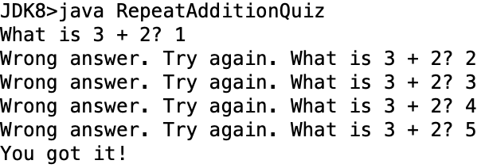

Do-While Loop
- Same as while loop, performs repeated execution but executes body of loop at least once
- Loop must end with ; to end loop
- Executes body first. Then checks condition

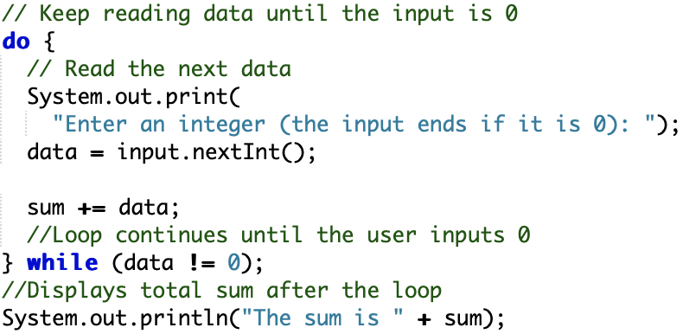
*Checks condition at “while (data 1!= 0);” here

For Loop
- For loops executed a loop for a certain amount of times, like it repeats 3 times
- For loops is the one place in your code when variable names like i or j
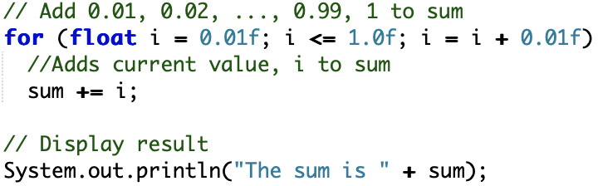
- The for loop is incrementing 0.01 continuously until it is over 1.0

Notes
- Use int in loop conditions. No double
- Don’t use semicolon for a while loop
- Use semicolon for do-while loop
- Avoid using break, forces the loop to stop immediately which is no good for structured programing
- While loops conditions is checked before the body is executed
- Do-while loops conditions is checked after the body is executed
- For loops conditioned are used to execute certain number of times
Sentinel Value - A java sentinel value can be used to notify the program to stop acquiring input.
- A sentinel value is simply a value that is used to terminate the while loop or do-while loop and stop getting inputs
- This is used when the user is done entering values
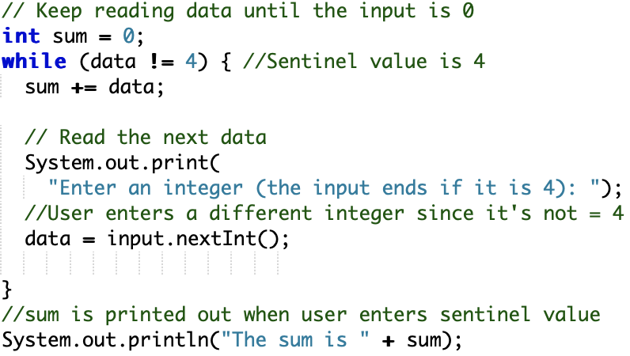

Nested Loops and Conditions

Nested For Loop
- Placing if-statements inside if-statements
- You can put a For loops in while loops or vice versa
- if/else conditions can be in loops and vice versa
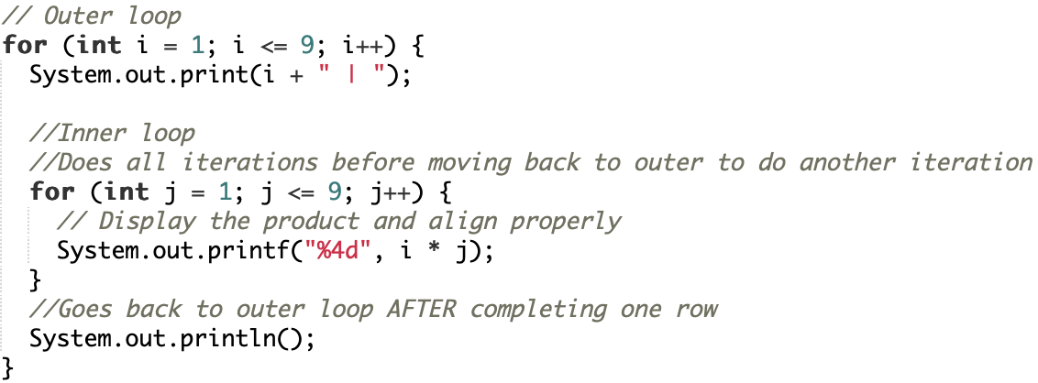

Nested While Loop
- You can place any type of loop inside another loop like Nested For Loop
- 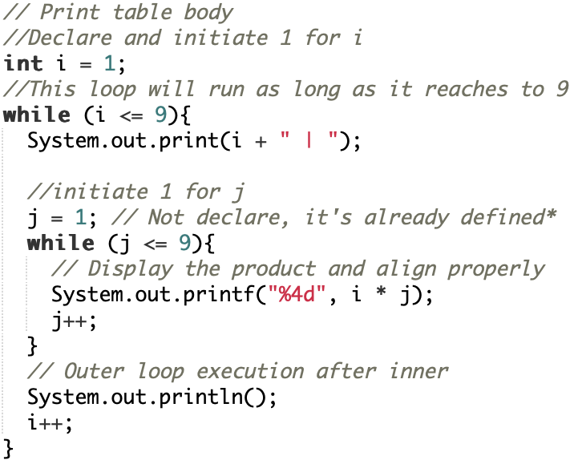

Note
- Use a “break” in only switch statements to end a case
- Don’t use a continue inside a loop

Methods
Parameter - Parameters is what holds a value inside the parentheses that passes to a method when it is called

Return Values - A return value is the value that is called by a method that must be stored in a variable.

If a method returns a value
- returnType must be a data type such as: String, Int, Double, etc. of the values that are being returned by the method
- This is used inside the method to return the value
If a method does not return a value
- returnType can be a “void”
- Return statement is not needed in the method

Predefined Methods - This is used to reuse code and break our problem into smaller tasks

Method Parameters - A method parameter are the number, order, and type of values that must match the same thing of the parameters declared in the method

Method Signature
- Name for method would be the one in green
- The parameters would be inside the parentheses
- This is returned as a double

Methods Pass by Value and Software Development

Call and Stack Frame
Call stack - This is used to keep track of active methods
- First one in would be the last one out
- Last one in would be the first one out
- When a method is called (invoked), that information of a method is a stack frame where it is pushed onto the stack (simply meaning to add).

- For instance, a method has been created, the main method will run first but as soon as it gets to a different method, it will run until it is completely executed while the information from the main has been deallocated from memory.

Memory and Calling Methods
- Calling methods allocates memory in a new location
- When variables are declared in method, there will be a new memory allocates

Pass by Values - Passing primitive data types from one method to another

- Pass by values is a copy of the value from one memory location that is passed into another memory location
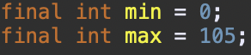
- This is from main method
- Min and max has been put into a different memory location(method)

Decomposition - Breaking into smaller pieces

Agile - The ability to create and respond to change quickly

Module 4
[ADD Headings 2 for the different topics then add your documentation from the lectures]

Arrays and Memory
Method Stack Memory and Heap Memory

Arrays
- An array is a data structure where more than one value can be stored in a container but they must be the same data type.
- An array is a group of contiguous memory locations
- Why use arrays?
- Gives the ability to access a specific set of values through one variable name
- Also provides the ability to store a fixed set of values with the same data type

Declaring Arrays
- This is an int element type the array is storing
- Variable name is numberOfApples which is a “reference” variable to the array
- Example: int[] numberOfApples;

Declaring and Creating a New Array: Memory
- Declaring an array creates memory on the stack to store the address to where the array will be in memory on the heap
- The TOTAL_NUMBERS is an object that is assigned to a new array that hold 5 integers which creates memory on the heap on needing 5 integers
- This allows the reference variable to have a memory address on the heap where the array starts at index 0. Heap is not on the stack
- With 5 indexes, each integer is stored consecutively in heap memory

Array Size
- Once a new array is created, the size of it can’t be changed
- “Length” is a property of an array object
- The length command cannot be changed after the array is created

Rules for Arrays
- Array declaration does not allocate memory for an array
- All elements will have the same type in an array

Stack and Heap

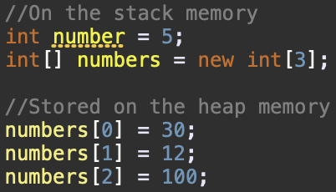
- Primitive data type is 5
- Reference variable is numbers
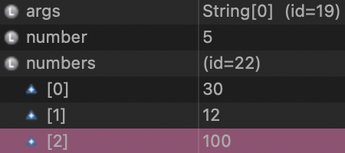
- On the heap, I have an address of id=22 where the numbers of the array are allocated
- Also, on the debugger it shows the number 5 which is on the stack from the first screenshot.

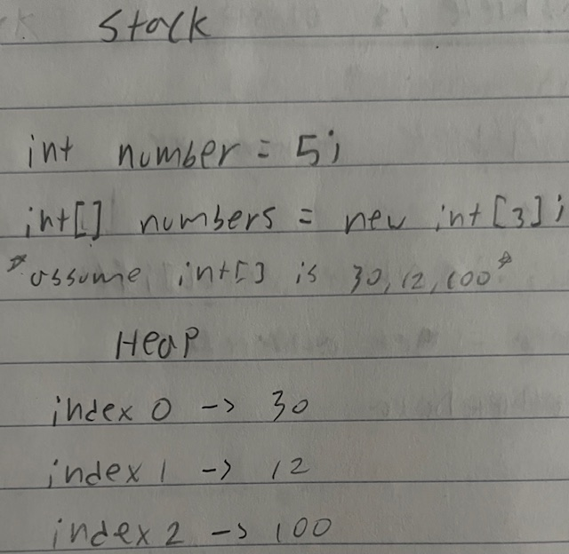

Pass and Return Arrays
Assigning Arrays

- Assigning a reference variable to another is different than assigning a primitive data type value of one variable to another
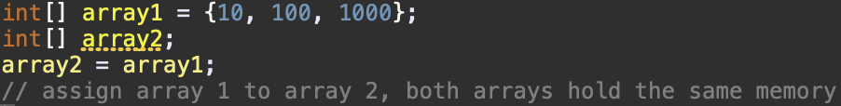
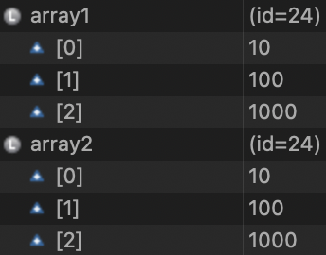
- Both array references variables carry the same address to the heap of id=24

Copy Arrays

- Use a loop to copy elements one by one
- Then initialize an empty array to an array that holds data
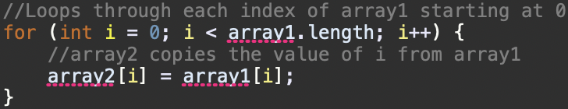

Passing Arrays By Reference

Pass by reference: a memory address which defines where the value is stored somewhere on the heap when is passed
- A reference to the heap memory where the array starts at [0] is sent to the method where it has the address of the array, so any changes it makes to the array, it will only occur to the original array and not a copy
- The original array outside of the method is affected by changes within the method, both are referencing the same heap memory address (id)

Passing by Reference and by Value

- Pass by reference means a memory address is passed which defines where in memory information is stored in the heap
- Pass by value means a copy of where the original value is passed on

Write to File and Design a Solution
File Output

- System is the class name and out is an instance of the System class to access methods to print out to the console
- Java File Class is an abstract representation of file and directory pathnames–can be either absolute or relative
- Java PrintWriter class is used to print the formatted information to a file output stream
- Always close PrintWriter with .close()

File class

- Data stored in files stays even after the program exits
- Provides an abstract
- File class contains methods for renaming and deleting files or directories, and they’re strings
- It cannot read from files, write to files nor create new files

Writing to a File

Pre and Post Conditions
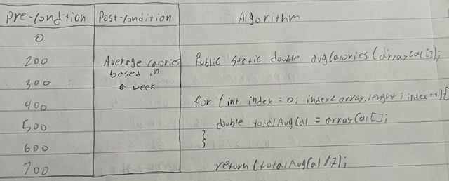

- The precondition is the amount of calories a week is burned
- The post-condition is the total average of calories was burned within a week
- The algorithm uses a for loop to calculate the average since there’s 7 indexes that can be listed in an array

Stack Memory for Methods
- When a method is called, there will be a new stack for that method only
- For example, main method has its own stack and method has its own as well
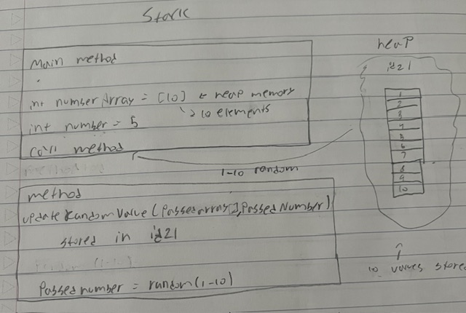

- The main method stack has a copy of the value 5 to be passed on to another stack
- Method holds the copy of the int number from the main and it is named PassedNumber
- In the main method, reference variable numberArray is created and passed to the method
- The array holds 10 indexes in the heap address starting from 0
- This reference has been passed to the method named Passedarray to be randomized from 1 to 10 and change the stack memory from the main

2 Dimensional Arrays
- One dimensional arrays represents linear sequence of elements
- Two dimensional arrays represent a matrix or a table as a spreadsheet
- Rows and columns

Declare and Initialize 2D Array

- This is the declaration of a two dimensional array
- Uses two sets of brackets “[][]” adjacent to type to indicate a 2D array
- To initialize, it also uses two brackets for number of rows and columns

Initialize 2D Array with Nested For Loops

- Must be declared first as shown above
- Then use a Nested for loop to have a loop for rows and a nested for loop for columns
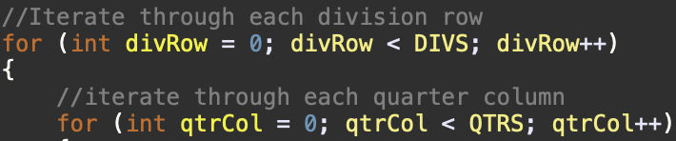

Module 5
[ADD Headings 2 for the different topics then add your documentation from the lectures]

Objects and Classes

OO Programing
- Object-oriented programming (OOP) builds large scale software systems. OPP is centered on using objects in programming.
- An object represents an entity that can be identified, even in the real world. It has two main characteristics: state and behavior
- State (Instance variables) - The state of an object has a set of data fields, (in other words; attributes and properties) such as name, size, etc. with their current values.
- Behavior - The behavior of an object is what the method can do.

Overloading Methods
- Method overloading is when a class has several methods with the same name but different parameters lists.
- Ex: getArray(int age)/(String name)/(double weight) etc.

Classes
- Classes are constructs that defines objects of the same data type
- Constructors, a special type of methods that are invoked to construct objects from the class scope
- Class is not a real world entity. It is a blueprint in which objects are created
- Class does not occupy memory
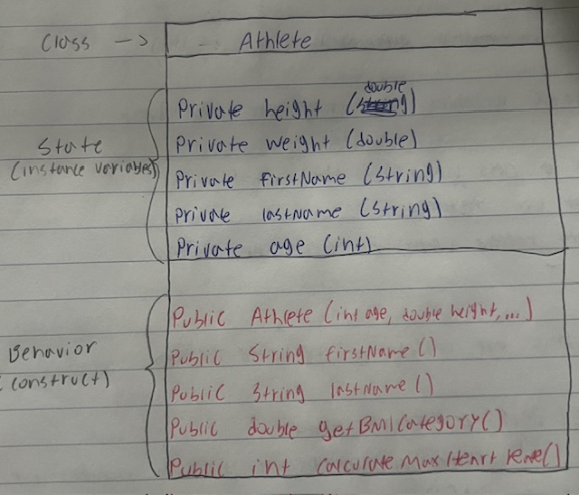

Constructor
- A constructor is like a special “method” when an instance is created with no return type.
- Has the exact same name as the class
- A constructor can overload, meaning it can hold multiple constructors with different parameters
- There is no return type. Including void
- Can be used to initialize the data fields
- It is not necessary to include a constructor in a class

Instance Variables
- A variable that is part of an instance within a class
- Instance variables is a state of an object about knowing itself entity
- For example, this image shows instance variables for being created in a class
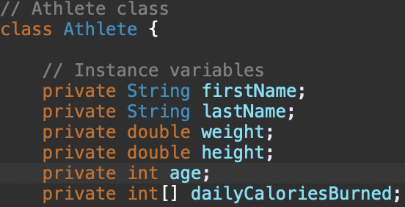

Instance Methods
- Methods that are part of an instance in a class
- Only executed through a reference to an instance
- Instance methods is the behavior of an object such as what it can do
- Instance methods can access both instance and static variables or methods
- You can see there is no static, and each of these methods can do to the instance variables

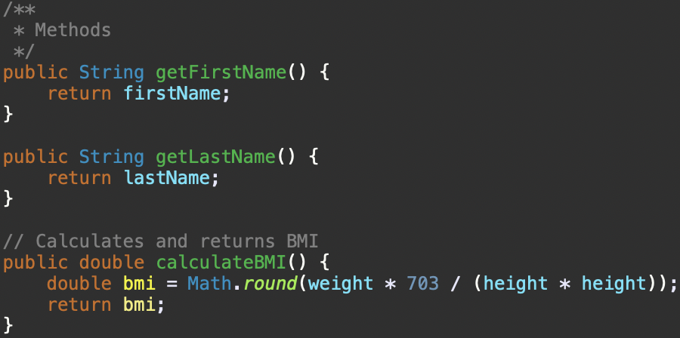

Static Methods
- Can access static variables but not instances
- Can access static methods but not instances

Dot Operator
- Access the data fields and methods of an object
- For instance: “Input.____” Gives you variety of methods

Scanner Class
Scanner userInput = new Scanner (System.in)
- Scanner is a data type of a blueprint
- userInput is a reference variable that isn’t stored on the stack
- Scanner is a class
- Scanner(System.in) is a construct that construct an object

Null
- Default value for references type
- A special literal that represents nothing to a value

Encapsulation
- Encase information to be exposed from data hiding (private) in a class to all instance variables
- Exposes data members to be used by the dot operator
- Creates getters and setters

Getter
- A method that returns the value of an instance variable
This get’s the first name of an athlete from a different class. Uses the dot operator to use the method to another method from another class. This is also a way to call Static Method.

Setter
- A method that sets the value of an instance variable
- Use setters to assign a new value to a private variable

Static Variables
- A shared variable by all objects in a class
- Static Variable is also called a Class Variable
- Only one copy exists no matter the number of instances of the class

Visibility Modifiers
Public - A public class indicates a method or variable can be accessed from any other class in a program
- Can apply on both methods and variables

Private - A private class indicates a method or variable can only be accessed within the class
- Can only apply methods and variable of that class

this
- Use the this reference when accessing an instance variable
- For example, I can access the firstName and lastName
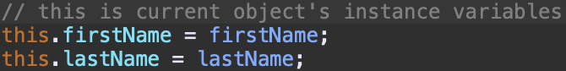

Array of Objects
- An array of objects is an array reference values that holds an address where each reference is located on the heap
Example:
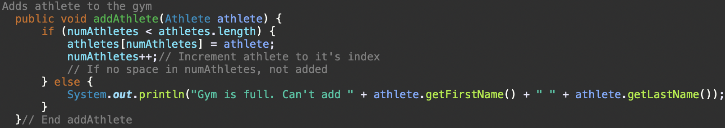
An athlete is added to the gym array through this method inside the Gym class.

This is the method where it reads athlete’s data from a file, and creates an athlete object where it stores athletes to the gym.

Notes*
Instance variables are in the class and they can be accessed in methods within the class.
Create a constructor to create instance
Encapsulation: instance variables are going to be private and must create getters and setters, but we don’t always create getters and setters.

